PRE-REGISTRATION

DEADLINE MAY 15th -2015

Names: ________________________

Address: _______________________

City: ___________________________

State: ______ Zip: _______________

Pre Registering $80 =____X
With T-shirt $100= ______X
With Hoodie $120= _____X

New comer Donation: $_______________

Total: $___________

-----------------------------------------------------------
Please send checks too
678 S. Fawn st
Cornelius, OR, 97113

Direction for the Retreat

From I-205
Take exit 12A to merge onto OR-212/224 E
Toward Clackamas and Estacada
Follow OR-224 left toward Estacada
Turn left onto Wildcat Mountain Drive, 1 mile
Past the junction for OR-211
Make a slight right onto Eagle Fern Road
Pass Eagle Fern Park and turn right onto
Snuffin Road
Turn left onto Camp Road

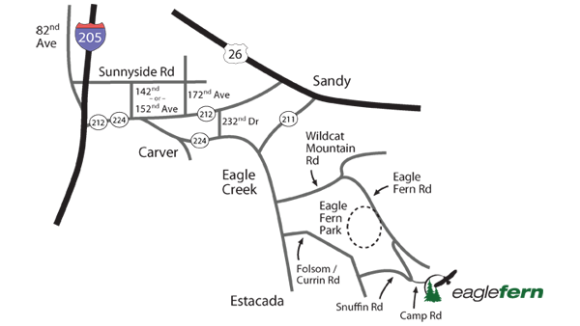

Forest Grove Men’s Retreat 2016
Eagle Fern Campgrounds
37700 SE Camp Rd. Estacada OR 97023
Date: June 14.15.16 2019

This year’s theme:
In the Spirit of Brotherhood

FRIDAY’S AGENDA

REGISTRATION Opens at 3:00pm
SIGN UPS FOR ACTIVITIES 3:00pm
DINNER 7:00pm
SPEAKER MEETING 8:00pm
CAMPFIRE MEETING 11:00pm

SATURDAY’S AGENDA

BREAKFAST 7:00am
REGISTRATIONS 8:00am
WORKSHOPS 9-11:30am
Workshop A 9am
Workshop B 10:30am
LUNCH 12:00pm
TOURNAMENT OF ACTIVITIES 1:00pm
DINNER 6:00pm
SPEAKER MEETING 8:00pm
AUCTION 9:00pm
CAMPFIRE MEETING 11:00pm

SUNDAY’S AGENDA

BREAKFAST 7:00am
ELECTIONS 8:30am
SPEAKER MEETING 9:00am
CLEAN –UP 10:00am
CLOSING 12:00pm

WORKSHOPS

Brotherhood
Time: 9am-10am, Sat.

Telling the Truth
Time 10:30am-11:30am, Sat.

ACTIVITIES
Signups are at registration

PINOCHLE TOURNAMENT
Starts at 1pm
Single elimination play to 500
Double deck pinochle cards
HORSESHOE TOURNAMENT
Starts at 1pm
Single elimination
Partners only
BASKETBALL 3 ON 3 TOURNAMENTS
Starts at 3pm
Single elimination
Must have 3 players to be eligible
No age requirement
SOFTBALL GAME
Starts at 4pm
Must bring your own gloves and bats
This is just for fun
Teams can be up to 9 players on each team

