Forest Grove Men’s Retreat Fundraiser 2019

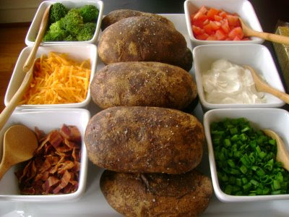

Potato bar All you can eat opens 3pm
Where: Reedville Church-2785 SW 209th ave, Aloha
When: February 23rd from 4pm to 8pm
Speaker meeting starts at 5:30pm
Cost $10 per person for Potato Bar
Everyone is welcomed
Message is free

