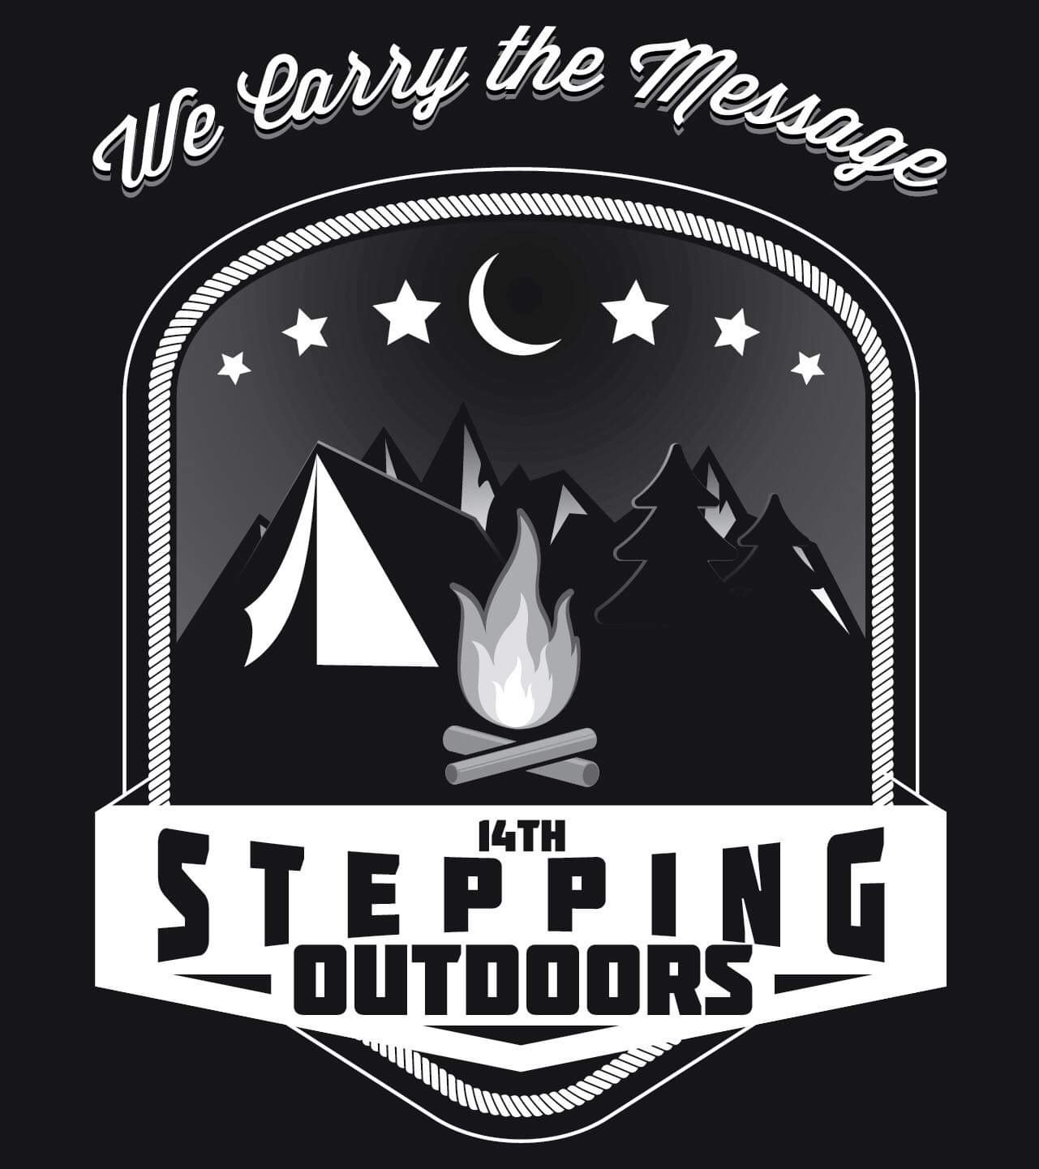
- Campsites are $65: includes one tent and one car.
- Up to two additional tents maybe added for $15
- Additional vehicles are $5 ( maximum of three)
- Please check in with the park hosts AND committee upon arrival
- Committee sites located at the Cabins located next to the parking lot near the park entrance
- All events, merchandise, and specified events will be held at the Cabins

get em’ while they’re hot!
-------------------------------------

Steppin’ Outdoors

2019 Barview Jetty
-------------------------------------
August 23rd-25th
Barview Jetty Campground
8200 – 8250 Cedar St. Rockaway Beach, OR 97136
LET’S GET IT POPPIN WASHINGTON COUNTY!

Children’s and adult activities Men and women’s meeting, Speaker meeting, Auction, Bonfire, Beach time, AND GENERAL GOOD TIME PROMISED!!

